University of Missouri - Kansas City

Summer 2020

BIG DATA PROGRAMMING

PROJECT 1

Part 1 – Facebook Mutual Friend Hadoop Map Reduce

Done by:

Uyen Dang ~ 16227610

Algorithm ???

Mapper???

Reducer???

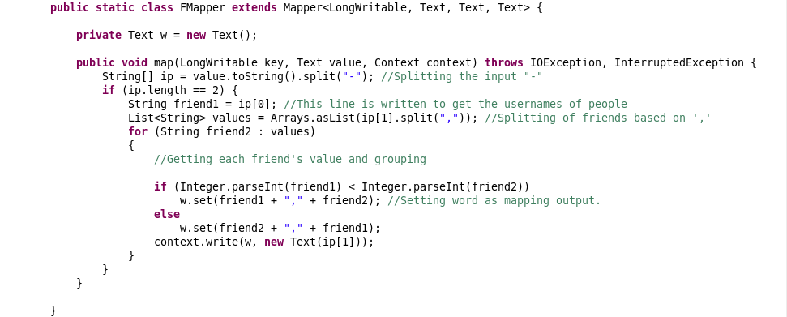

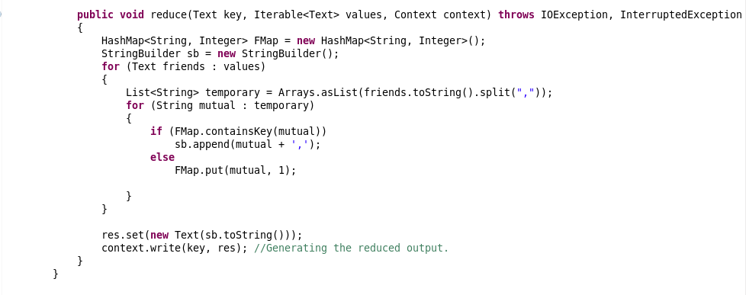

Step 1: Create a new PROJECT1 directory



Step 2: Push the input file to HDFS



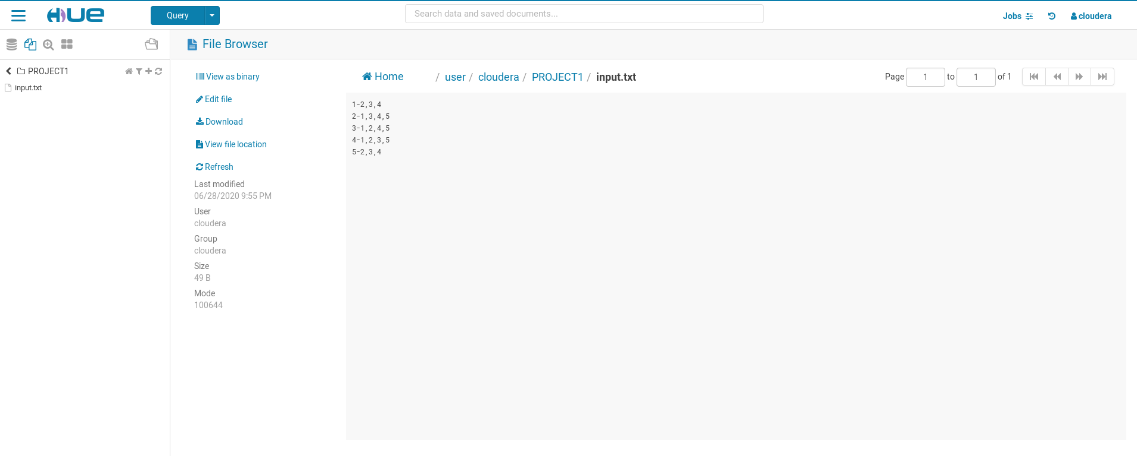

Step 3: Create a Java Project named PROJECT1

Import all JARS libraries

Create a Java class named PROJECT1

Export Java Project into a JAR file.

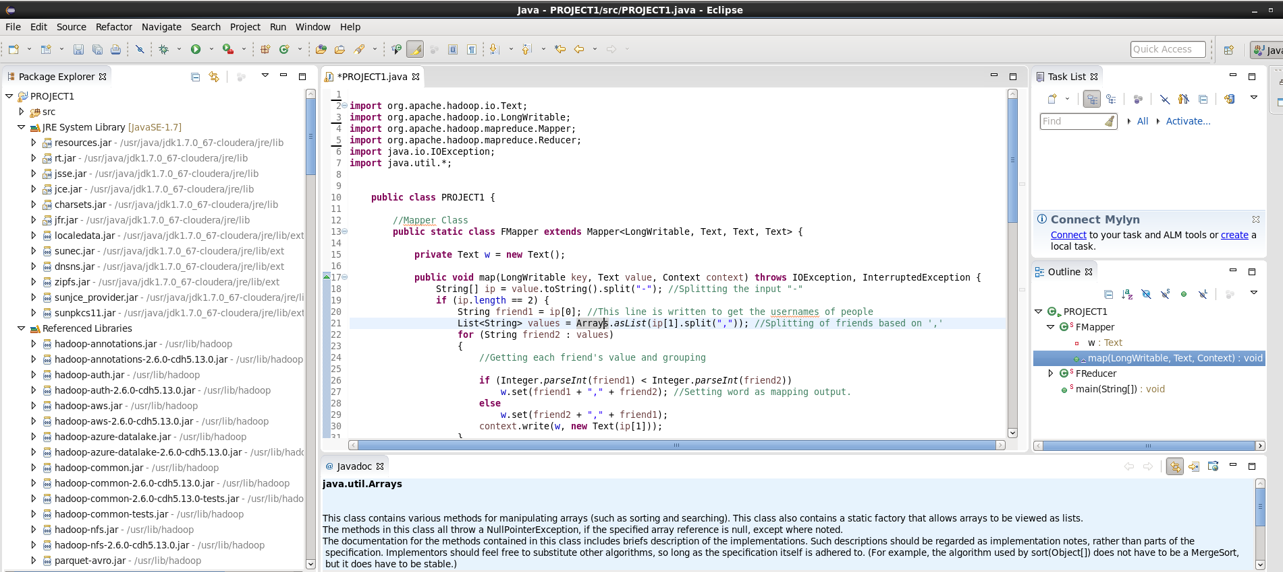

Step 4: Run MapReduce Job



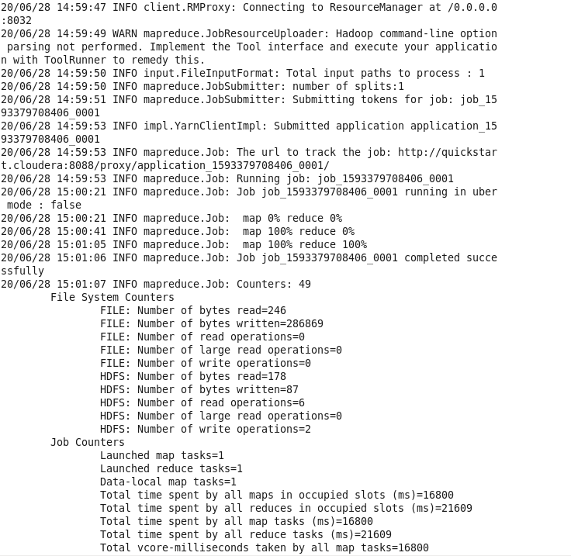

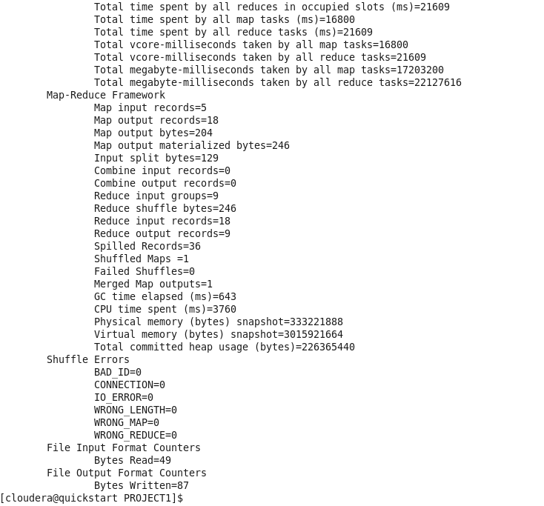

Step 5: Check the output on Hue

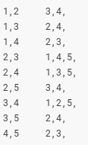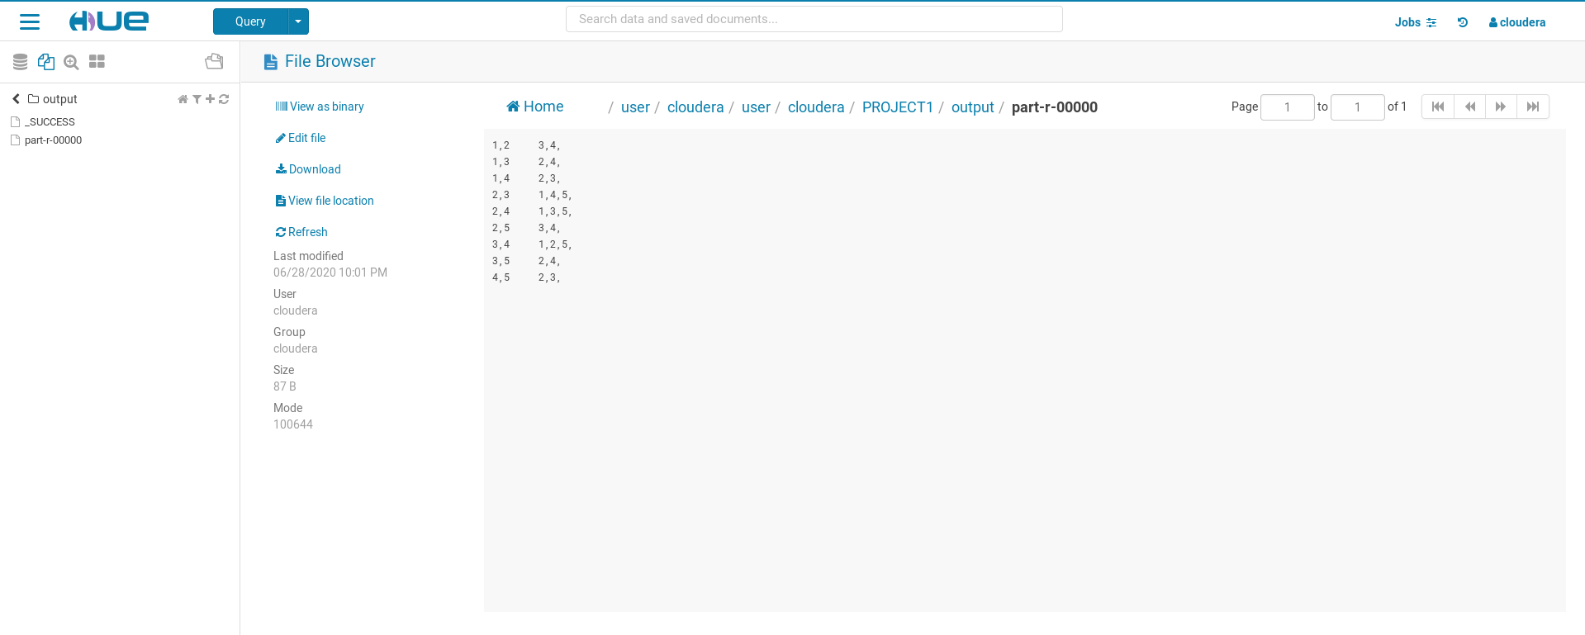

\*\*\*\*\*\*\*\*\*\*\*\*\*\*\*\*\*\*\*\*\*\*\*\*\*\*\*\*\*\*\*\*\*\*\*\* END PART 1 \*\*\*\*\*\*\*\*\*\*\*\*\*\*\*\*\*\*\*\*\*\*\*\*\*\*\*\*\*\*\*\*\*\*\*\*\*\*\*\*\*\*\*\*\*\*\*

REFERENCES:

<https://umkc.app.box.com/s/xk4jj0do3p7fa3swx6utcuazx3wny8j8>

<https://github.com/navyagonug/CS5590-BIG-DATA-PROGRAMMING-USING-HADOOP-AND-SPARK/tree/master/LAB-1>